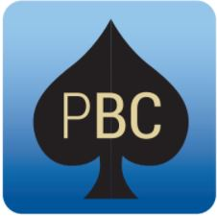
PENINSULA
BRIDGE CLUB
Nelson Heather Centre,
4 Jacksons Rd,
Warriewood NSW 2102
10am-5pm Sunday 15 July 2018
Representing Peninsula in the

Sydney North Interclub Pairs

More info about the event - http://bit.ly/2018SydNthPairs
Conducted under the auspices of the NSW Bridge Association. The Australian Bridge Federation has approved the issue of red masterpoints at level B5i.
Event Details
- Last year Peninsula won the interclub pairs by half a point – can we win it again?
- One fun day, two sessions, two fields, six categories to ensure everyone can contribute to the club’s chances, red masterpoints
- We want our best pairs from rookies up
- Members are encouraged to bring a plate to share
- Entry fee - $25 per person – includes light lunch, and member provided finger food, and wine, juice and cheese at the end of play
- Director – John McIlrath

Prizes
- None – just play for the fun and the glory
- Be part of a winning fun team
How to enter
- Entry is initially by invitation to pairs who have done well over the last year
- We will then look at those who express their interest below
Inquiries?
- Inquiries to the Convener – Cassandra Mitchell, cassandra.
l.mitchell@gmail.com or 0421 764 300

